

**Name: Esha Shahzad**

**Sapid: 55593**

**Course: Coal Lab**

**Instructor: Mam Fareeha**

**Task # 1:Write a program to print small letters**

org 100h

.model small

.stack 100h

.data

.code

main proc

mov cx,26

mov dx, 97

print:

mov ah,2

int 21h

inc dx

Loop print

mov ah,4ch

int 21h

main endp

end main

**Output:**

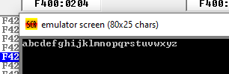

**Task # 2**

**Write program to input character from user**

**Program display 10 times**

org 100h

.model small

.stack 100h

.data

msg db 'Enter a digit: $'

digit db 0

.code

main proc

mov ax, @data

mov ds, ax

mov dx, offset msg

mov ah, 09h

int 21h

mov ah, 01h

int 21h

mov digit, al

mov dl,32

mov ah,2

int 21h

mov dl, 10

mov ah,2

int 21h

mov dl, 13

mov ah,2

int 21h

mov cx, 10

print_digit:

mov dl, digit

mov ah, 02h

int 21h

mov dl, 10

mov ah,2

int 21h

mov dl, 13

mov ah,2

int 21h

loop print_digit

mov ah, 4Ch

int 21h

main endp

**Output:**

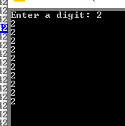

**Task # 3:Write a program to add frist 3 numbers**

.model small

.stack 100h

.data

msg db 'Enter number: $'

resultMsg db 'Sum is: $'

result db 0

.code

main proc

mov ax, @data

mov ds, ax

mov cx, 3

add bx, bx

inputloop:

mov dx, offset msg

mov ah, 09h

int 21h

mov ah, 01

int 21h

sub al, '0'

add bl, al

mov dl, 13

mov ah, 2

int 21h

mov dl, 10

mov ah, 2

int 21h

loop inputloop

mov result, bl

mov dx, offset resultMsg

mov ah, 09h

int 21h

mov al, result

add al, '0'

mov dl, al

mov ah, 02h

int 21h

mov ah, 4Ch

int 21h

main endp

end main

**output:**

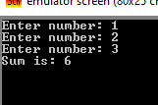

**Task # 4:Write a program tp print odd numbers in reverse order**

**.**model small

.stack 100h

.data

.code

main proc

mov cx,5

mov dx, 57

printdigits:

mov ah,2

int 21h

dec dx

dec dx

Loop printdigits

mov ah,4ch

int 21h

main endp

end main

**Output:**

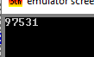

**Task # 5:Write a program to print odd numbers in correct order**

.model small

.stack 100h

.data

.code

main proc

mov cx,5

mov dx, 49

printdigits:

mov ah,2

int 21h

inc dx

inc dx

Loop printdigits

mov ah,4ch

int 21h

main endp

end main

**output:**

